Test Case: runTestMultipleTimes
Step 1 - Enter username and password and click to button Enter : Credentials Entered
Image file-name: QC_Testing-runTestMultipleTimes-dic. 04 2025, 03 38 29 p. m.

Image file-name: QC_Testing-runTestMultipleTimes-dic. 04 2025, 03 38 30 p. m.

Step 2 - Select to UEN and Access to Administrador Roles Menu: UEN Correctly selected and Correct access
Image file-name: QC_Testing-runTestMultipleTimes-dic. 04 2025, 03 38 35 p. m.

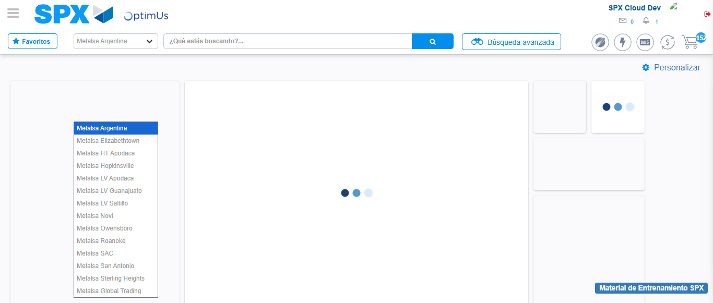Image file-name: QC_Testing-runTestMultipleTimes-dic. 04 2025, 03 38 38 p. m.

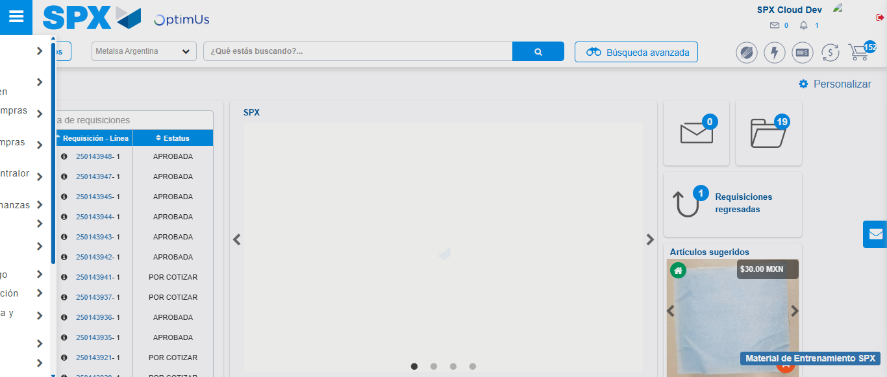Image file-name: QC_Testing-runTestMultipleTimes-dic. 04 2025, 03 38 39 p. m.

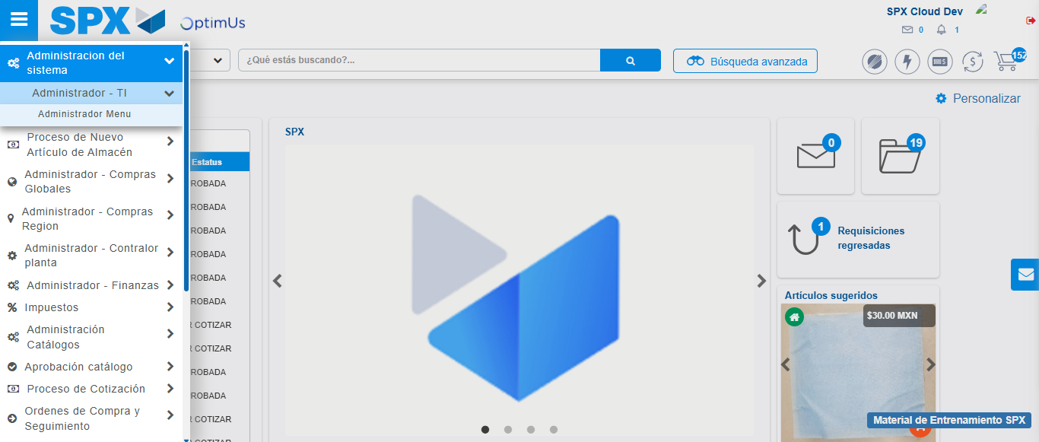Image file-name: QC_Testing-runTestMultipleTimes-dic. 04 2025, 03 38 40 p. m.

Image file-name: QC_Testing-runTestMultipleTimes-dic. 04 2025, 03 38 42 p. m.

Step 3 - Click to Buttons View Menu and Search Filter with Menu Name and Add new record and Delete Record: Correct Search and Record successfully added and Record successfully deleted
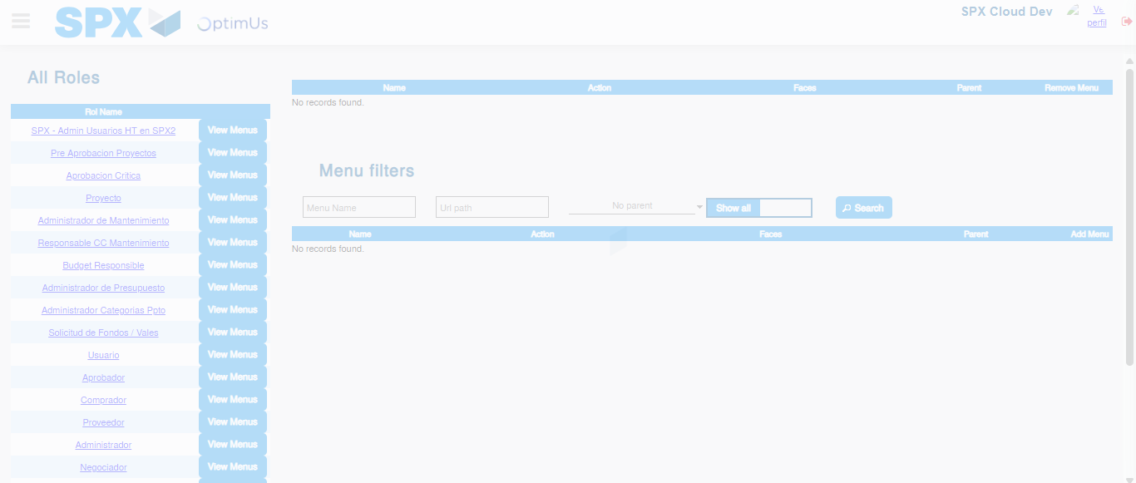Image file-name: QC_Testing-runTestMultipleTimes-dic. 04 2025, 03 38 43 p. m.

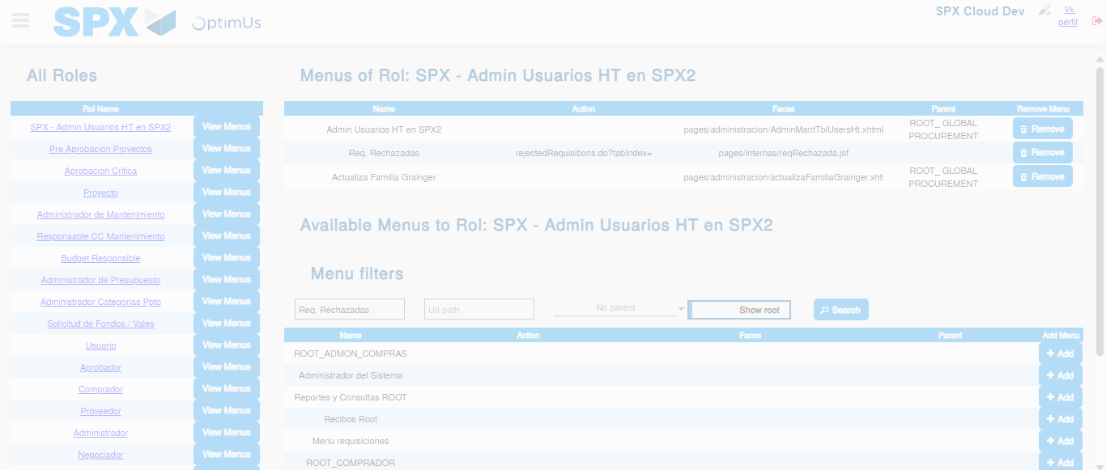Image file-name: QC_Testing-runTestMultipleTimes-dic. 04 2025, 03 38 44 p. m.

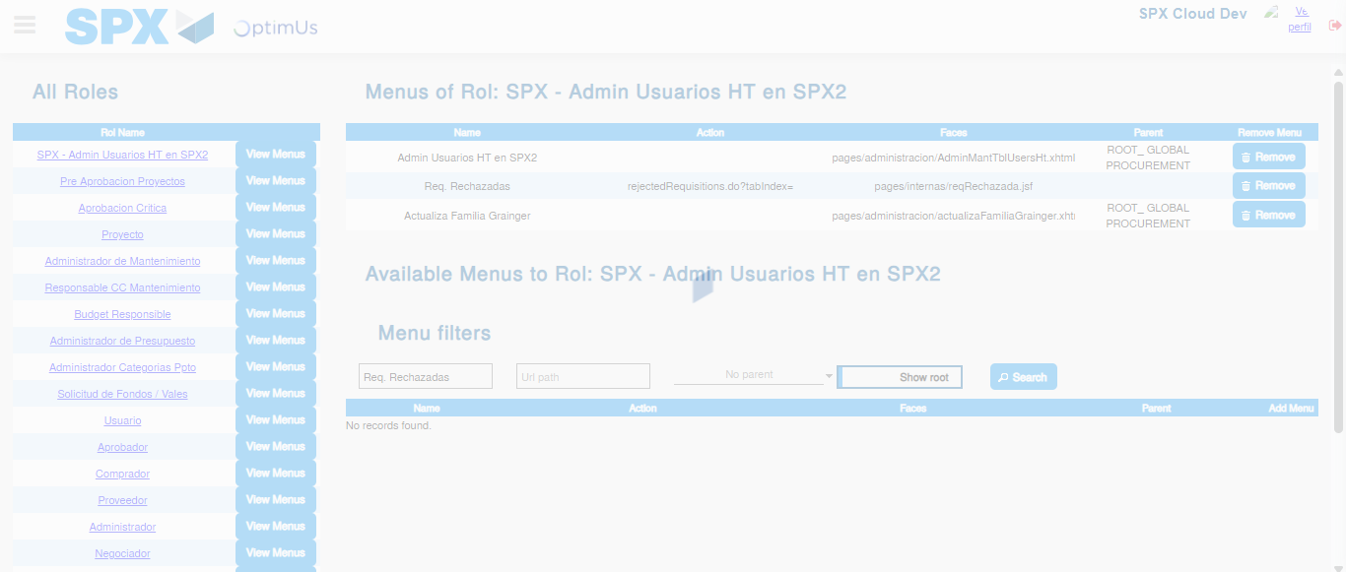Image file-name: QC_Testing-runTestMultipleTimes-dic. 04 2025, 03 38 45 p. m.

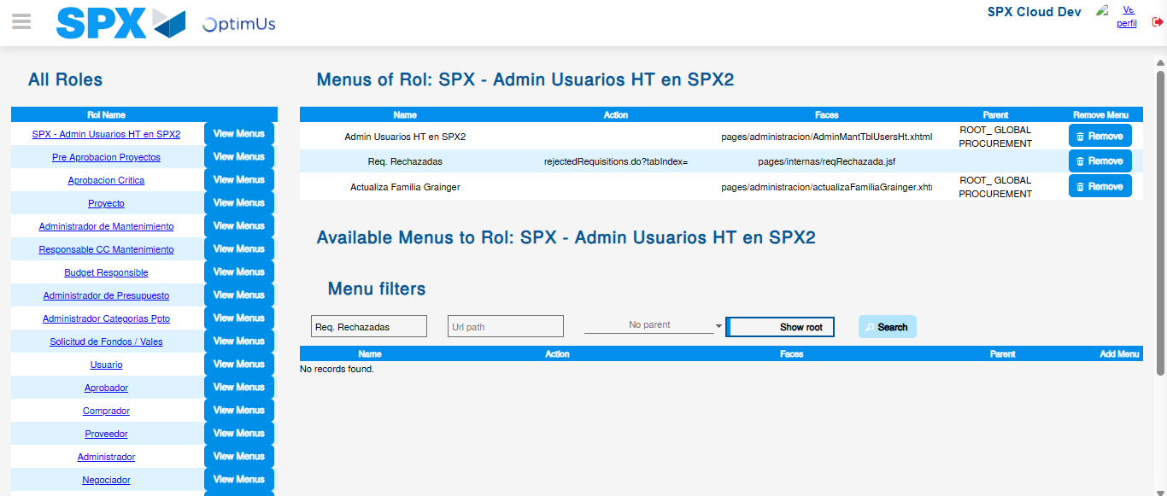Image file-name: QC_Testing-runTestMultipleTimes-dic. 04 2025, 03 39 13 p. m.

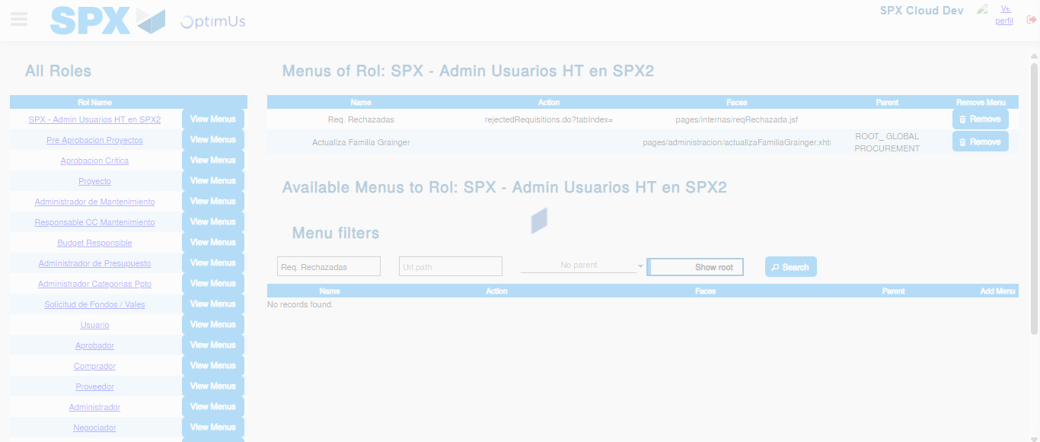Image file-name: QC_Testing-runTestMultipleTimes-dic. 04 2025, 03 39 14 p. m.

